**Anotações POO 2**

**SEMANA 1 – 04/11/2021 A 08/11/2021**

* Instando o plugin WindowBuilder: file>new>other>window builder>SWING DESIGNER > APPLICATION WINDOW

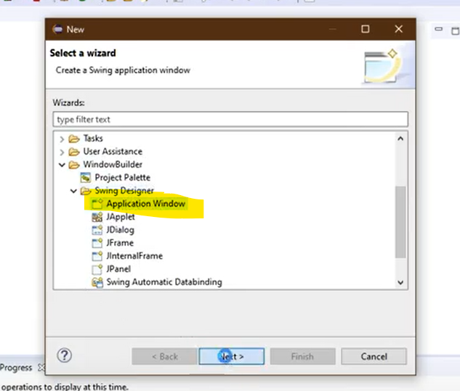

* Aula 1: <https://www.youtube.com/watch?v=FQgQZEWWdcs&t=7s>